**COMPETITIVE ANALYSIS OF LEADING TRAVEL AGGREGATORS**

**DATA ANALYTICS**

# NAAN MUDHALVAN PROJECT REPORT

***Submitted By***

# GNANAVEL P (611220104304)

**VENKATAPATHY R (611220104319)**

# SATHYASEELAN A (611220104313)

**SUDHARSANAN V (611220104316)**

***in partial fulfillment for the award of the degree***

***of***

## BACHELOR OF ENGINEERING

***in***

**COMPUTER SCIENCE AND ENGINEERING**

# KNOWLEDGE INSTITUTE OF TECHNOLOGY,

## SALEM-637504

**COMPETITIVE ANALYSIS OF LEADING TRAVEL AGGREGATORS**

**DATA ANALYTICS**

# NAAN MUDHALVAN

# PROJECT REPORT

***Submitted By***

# GNANAVEL P (611220104304)

**VENKATAPATHY R (611220104319)**

# SATHYASEELAN A (611220104313)

**SUDHARSANAN V (611220104316)**

***in partial fulfillment for the award of the degree***

***of***

## BACHELOR OF ENGINEERING

***in***

**COMPUTER SCIENCE AND ENGINEERING**

# KNOWLEDGE INSTITUTE OF TECHNOLOGY,

**SALEM-637504**

# BONAFIDE CERTIFICATE

Certified that this project report titled **“COMPETITIVE ANALYSIS OF TRAVEL AGGREGATTORS USING DATA ANALYTICS”** is

## the bonafide work of “GNANAVEL P(611220104304), VENKATAPATHY R(611220104319), SATHYASEELAN A(611220104313), SUDHARSANAN V(611220104316)” who carried out the project work under my supervision.

|  |  |
| --- | --- |
| **SIGNATURE** | **SIGNATURE** |
| Dr. V. KUMAR M.E., Ph.D., | Mr. M.GOPIKUMARAN B.Tech.,M.E., |
| **HEAD OF THE DEPARTMENT** | **FACULTY MENTOR** |
| **PROFESSOR** | **ASSISTANT PROFESSOR** |
| Department of Computer Science | Department of Computer Science |
| and Engineering, | and Business System, |
| Knowledge Institute of Technology, | Knowledge Institute of Technology, |
| Kakapalayam, | Kakapalayam, |
| Salem- 637 504. | Salem- 637 504. |
| **FACULTY MENTOR** | **HEAD OF THE DEPARTMENT** |

# ACKNOWLEDGEMENT

At the outset, we express our heartfelt gratitude to **GOD,** who has been our strength to bring this project to light.

At this pleasing moment of having successfully completed our project, we wish to convey our sincere thanks and gratitude to our beloved president **Mr. C. Balakrishnan,** who has provided all the facilities to us.

We would like to convey our sincere thanks to our beloved Principal **Dr. PSS. Srinivasan,** for forwarding us to do our project and offering adequateduration in completing our project.

We express our sincere thanks to our Head of the Department **Dr. V. Kumar,** Department of Computer Science and Engineering for fostering the excellent academic climate in the Department.

We express our pronounced sense of thanks with deepest respect and gratitude to our Faculty Mentor **Mrs. M. Saranya,** Assistant Professor, Department of Computer Science and Engineering for their valuable and precious guidance and for having amicable relation.

With deep sense of gratitude, we extend our earnest and sincere thanks to our SPOC **Mr. T. Karthikeyan,** Assistant Professor, Department of Computer Science and Engineering for his guidance and encouragement during this project.

We would also like express our thanks to all the faculty members of our Department, friends and students who helped us directly and indirectly in all aspects of the project work to get completed successfully

**TABLE OF CONTENTS**

|  |  |  |
| --- | --- | --- |
| **CHAPTER**  **NO** | **TITLE** | **PAGE NO** |
|  | **ABSTRACT**  **LIST OF FIGURES**  **LIST OF ABBREVIATIONS** | I II III |
| 1 | **INTRODUCTION** |  |
|  | 1.1 Project Overview | 1 |
|  | 1.2 Purpose | 3 |
| 2 | **LITERATURE SURVEY** |  |
| 3 | **IDEATION & PROPOSED SOLUTION** |  |
|  | 3.1 Problem Statement Definition | 5 |
|  | 3.2 Empathy Map Canvas | 7 |
|  | 3.3 Ideation & Brainstorming | 8 |
|  | 3.4 Proposed Solution | 11 |
| 4 | **REQUIREMENT ANALYSIS** |  |
|  | 4.1 Functional requirements | 13 |
|  | 4.2 Non-Functional requirements | 14 |
| 5 | **PROJECT DESIGN** |  |
|  | 5.1 Data Flow Diagrams | 15 |
|  | 5.2 Solution & Technical Architecture | 16 |
|  | 5.3 User Stories | 18 |
| 6 | **CODING & SOLUTIONING** |  |
|  | 6.1 Feature 1 | 20 |
|  | 6.2 Feature 2 | 22 |
|  | 6.3 Feature 3 | 24 |
|  | 6.4 Database Schema | 26 |
| 7 | **RESULTS** |  |
|  | 7.1 Performance Metrics | 27 |
| 8 | **ADVANTAGES & DISADVANTAGES** | 39 |
| 9 | **CONCLUSION** | 41 |

|  |  |  |
| --- | --- | --- |
| 10 | **FUTURE SCOPE** | 43 |
| 11 | **APPENDIX** |  |
|  | A.1 Source Code | 45 |
|  | A.2 GitHub & Project Video Demo Link | 52 |

# ABSTRACT

A travel aggregator is a website or platform that allows users to search and compare prices for travel-related products and services, such as flights, hotels, vacation rentals, and car rentals, from multiple providers. Travel aggregators typically provide a simple and convenient way for users to find and book travel products and services, and often offer additional features such as reviews, ratings, and photos to help users make informed decisions. Some popular examples of travel aggregator websites include Expedia, Booking.com, Kayak, and Trivago. Travel aggregators typically generate revenue by charging commissions or fees to the travel providers whose products and services are featured on their platform. Some also earn revenue through advertising, or by offering additional services such as travel insurance or car rental. An analysis of a travel aggregator can be a great opportunity to understand the travel industry trends, consumer preferences, and the impact of external factors on the travel industry. This can be done by analysing the data from the travel aggregator such as bookings, reviews, prices and other related data, which can be used to draw insights and make data-driven decisions.

# LIST OF FIGURES

|  |  |  |
| --- | --- | --- |
| **FIGURE NO** | **NAME OF FIGURES** | **PAGE NO** |
| 3.2.1 | EMPATHY MAP CANVAS | 7 |
| 2.3.1 | IDEATION AND BRAINSTORMING | 8 |
| 2.3.2 | BRAINSTORMING | 9 |
| 2.3.3 | IDEA PRIORIZATION | 10 |
| 5.1 | DATA FLOW DIAGRAM | 15 |
| 5.2.1 | SOLUTION ARCHITECTURE | 16 |
| 5.2.2 | TECHNICAL ARCHITECTURE | 17 |

**LIST OF ABBREVIATIONS**

|  |  |
| --- | --- |
| **ABBREVIATIONS** | **EXPANSIONS** |
| OTA | ONLINE TRAVEL AGGREGATORS |
| FR | FUNCTIONAL REQUIREMENTS |
| NFR | NON-FUNCTIONAL REQUIREMENTS |
| AR | AUGUMENTED REALITY |
| VR | VIRTUAL REALITY |

## INTRODUCTION



# CHAPTER 1 INTRODUCTION

## Project Overview

Travel aggregator is a website or platform that allows users to search and compare rates for travel- related items and services such as flights, hotels, vacation rentals, and auto rentals from many sources. Travel aggregators often offer an easy and convenient means for consumers to locate and book travel products and services, as well as extra features such as reviews, ratings, and images to assist customers in making educated decisions. Some popular examples of travel aggregator websites include Expedia, Booking.com, Kayak, and Trivago.

While travel aggregators make it easy to search for and compare travel options, users frequently struggle to find the best deals and promotions due to the overwhelming amount of information and options presented. The gathered data will next go through a thorough analysis utilizing statistical methods and tools for data visualization. The evaluation of rivals' pricing tactics, marketing initiatives, value-added services, and user experiences will be the main emphasis of the analysis. To measure consumer happiness and pinpoint trouble points, reviews, ratings, and client comments will also be analyzed.

Furthermore, the project will also keep tabs on new developments in the travel aggregator sector, as well as market opportunities and potential threats. To anticipate market movements and spot opportunities for growth and innovation, this will include keeping an eye on changes in the industry, technology improvements, and consumer preferences.

The competition analysis's results will give the travel aggregator useful information that will help it to improve its value proposition, sharpen its business strategy, and possibly achieve a competitive edge in the fast-moving travel market.

## Purpose

Now-a-days, by giving people a quick and easy way to plan and book their vacations, travel aggregators play a crucial role in the travel business. A travel aggregator's main function is to provide a centralized platform that compiles data from multiple travel service providers, including airlines, hotels, car rental agencies, and tour operators. By doing this, they make the process of organizing a trip simpler and help users save time and effort.

Users are empowered to evaluate costs, availability, and features of various travel services on these platforms, enabling them to make selections that are in line with their tastes and financial constraints. Additionally, travel aggregators offer thorough data about locations, lodgings, modes of

transportation, and attractions to make sure users have access to all the information they need to make informed travel plans. A travel aggregator's goal is to improve user experience by providing convenience, cost savings, and thorough information, making the process of planning, and booking travel easy and enjoyable.

The purpose of this research would be to better understand the user experience using travel aggregators, identify pain areas in the booking process, and make recommendations for improving the user interface and search capabilities to better fulfil the requirements and expectations of users.

## LITERATURE SURVEY



## CHAPTER 2 LITERATURE SURVEY

* 1. **Analysis and Application of Tourists’ Sentiment Based on Hotel Comment Data**

Bin Wu presented a paper which intends to analyze the tourist’s sentiment based on hotel comment data. Online travel agency (OTA) platforms are becoming more and more popular in today's world. When it comes to OTA platforms, hotels receive a higher number of comments from visitors, and authenticity is a crucial aspect. The data is gathered using the 'Bazhuayu' collector and prepared for analysis, with segmentation completed using jieba. Frequency-Inverse Document Frequency technique is used to extract keywords, and the Bagof-Words model is used to create a word vector. The dataset is balanced using subsampling, and to classify and adjust the parameters, support vector machine, Naive Bayes, and Long Short-Term Memory neural network models are established to compare their classification performance. Based on the classification results, suggestions are provided to assist hotels in optimizing and upgrading themselves.

## Determinants of OTAs Continuous Usage Intention

So Ra Min presented a paper which intends to the continuous Online Travel Agencies (OTA) usage intention. This study used the SOR model to apply information quality, OTA trust, and continuous usage intention offered by online travel agencies to examine their relationships. To do this, consumers who have made several OTA purchases within the previous year participated in an online survey. The SPSS v.22 and AMOS v.22 programmes were used to analyze the 234 replies and test the hypotheses. One might anticipate that this work will have academic ramifications. By identifying the elements that encourage customers' continued usage intentions, which are associated with the revenue of online travel agencies, it is anticipated that this study may be utilized as fundamental information to, in practise, develop a user-centered informative provision environment.

* 1. **OTA Optimization: Evaluating Consumers’ Purchase Intention from Online Negative Review Responses Analysis** Sheng ying Liu presented a paper on analysis of consumers purchase intention evaluation from online negative review responses. Consumers, however, increasingly rely on outside information when making purchases because of the drawbacks of internet buying and the immaterial nature of tourism service items. It has become crucial to figure out how to mine and analyze these data to understand consumers' purchase intentions for various response strategies and then design personalized response strategies data to deal with various service remedies, increasing service responsiveness and competitiveness. This study, which is based on the Attribution theory, assigns the online negative review responses gathered on the Online Travel Agency (OTA) platforms to three different types of response strategies before exploring the effects of various negative review response strategies on consumers' purchase intentions using a quantitative method. This work helps merchants manage their customer relationships and optimize their e-commerce applications.

# IDEATION & PROPOSED SOLUTION



**CHAPTER 3**

# IDEATION &PROPOSED SOLUTION

## Problem Statement Definition

|  |  |  |  |  |
| --- | --- | --- | --- | --- |
| **I am (Custome r)** | **I’m trying to** | **But** | **Because** | **Which makes me feel** |
| Traveller | Booking a flight through  mobile phone | 1.It takes a long time. 2.It is difficult in finding affordable flights that meet scheduling needs. | 1.It feels difficulty in finding the best offers and rates for flight can be difficult due to growing number of policies and booking services. 2.Airlines have wide range of policies that can be confusing and difficult for travelers to understand (ex:  baggage policies). | Dissatisfied |
| Traveller | Booking a hotel through mobile phone. | It takes a long time. | 1. The website doesn’t provide sufficient about the hotel details(i.e. vacancies of room, size of room ). 2. Website is not   responsive and | Aggrived |

|  |  |  |  |  |
| --- | --- | --- | --- | --- |
|  |  |  | doesn’t have a  mobile version. |  |
| Traveller | Booking a car rental through mobile phone. | It takes long time for finding a reliable car rental company. | 1. Travelers may face challenges in securing their needs such as limited budget. 2. They face many fraudulent car rental companies are there and many people got scammed by overrated rental   charges. | Disenchanted |
| Traveller | Booking a vacation rental through mobile phone. | 1.It takes lack of personalized recommendations. 2.Difficult in finding suitable accommodations and it takes a long time. | 1. It make difficulty finding trustworthy and dependable rental can be challenging because to growth of website (i.e. Airbnb, etc). 2. Lack of transparency in   pricing and fees. | Frustrated |
| Traveller | Booking a travel bus through mobile phone. | 1. It appears that they are having difficulty understanding the overall expense of their trip. 2. Lack of confidence in the booking procedure | 1.The process of booking travel bus through mobile it seems difficult mainly in payment systems such as the method that use to purchase their tickets it could brought on antiquated  payment | Suspicion |

|  |  |  |  |  |
| --- | --- | --- | --- | --- |
|  |  |  | alternatives, a lack of payment option.  2.Security for the customer data is secure and protected when booking for travel bus ticket through  online. |  |

* 1. **Empathy Map Canvas**

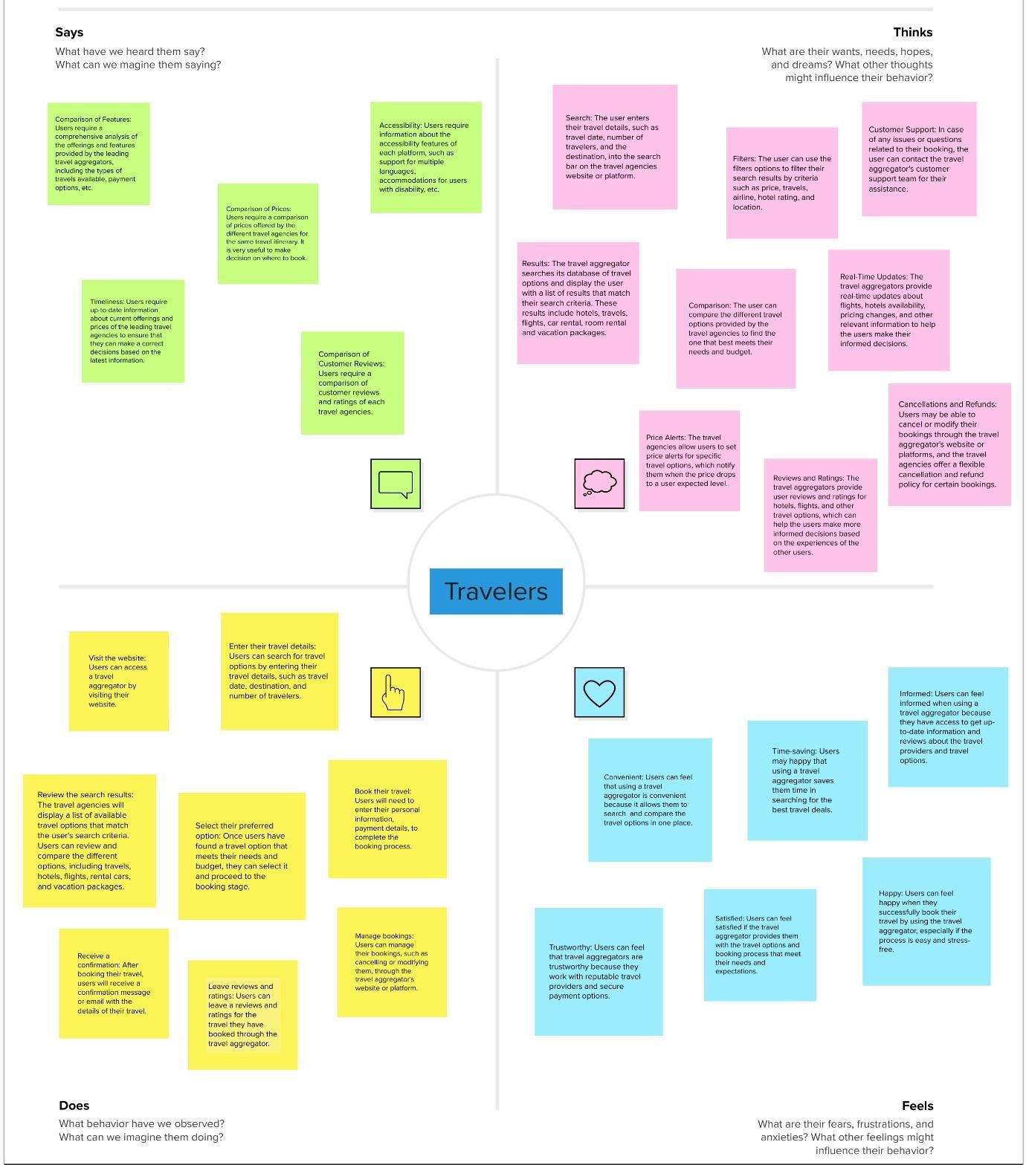

Fig 3.2.1 Empathy Map Canvas

## Ideation & Brainstorming

**Step-1: Team Gathering, Collaboration and Select the Problem Statement**

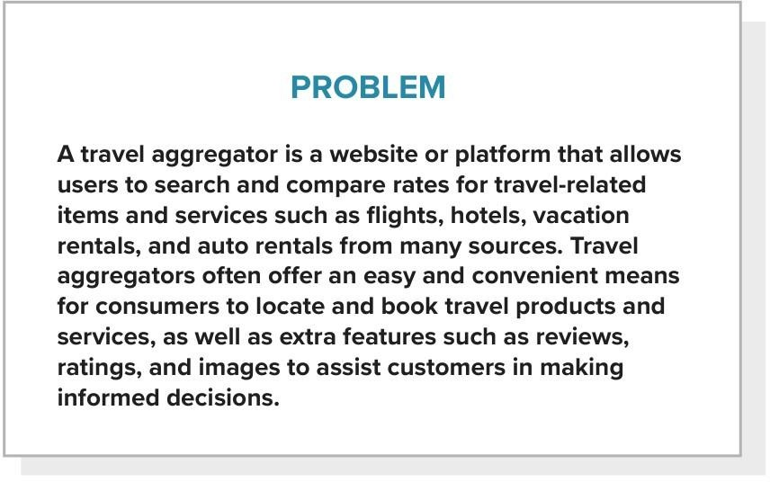

Fig 3.3.1 Problem Statement

## Step-2: Brainstorm, Idea Listing and Grouping

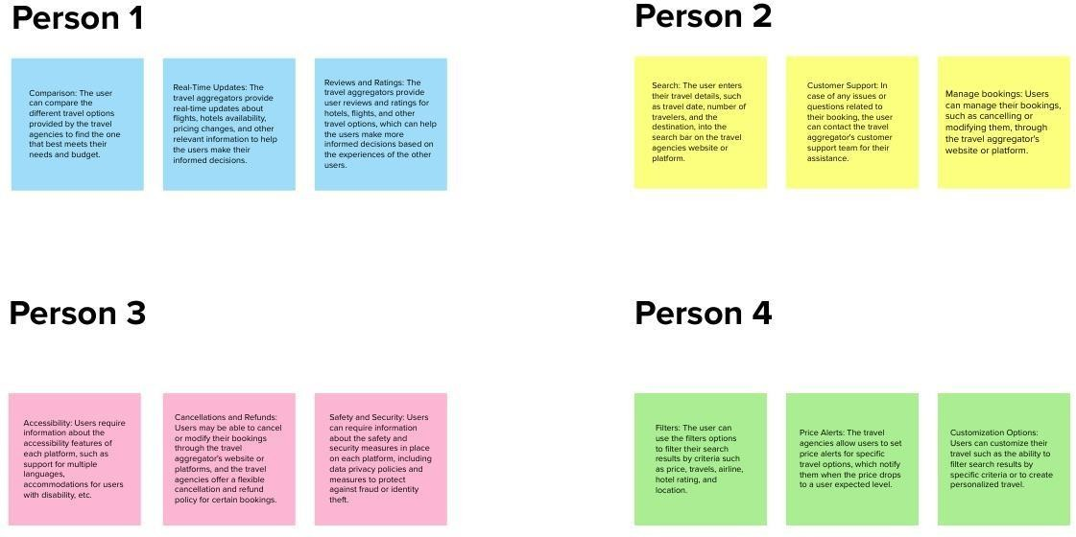

Fig 3.3.2 Brainstorming

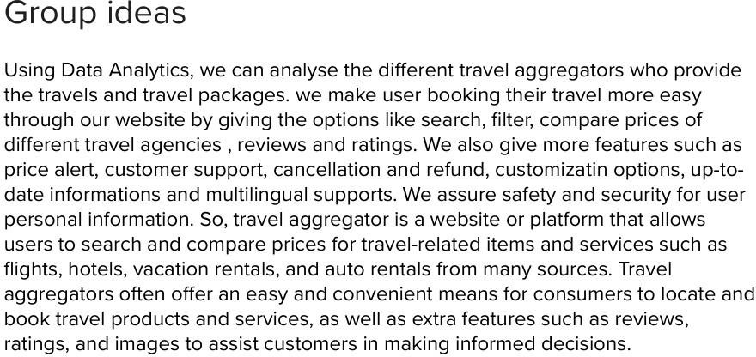

## Step-3: Idea Prioritization

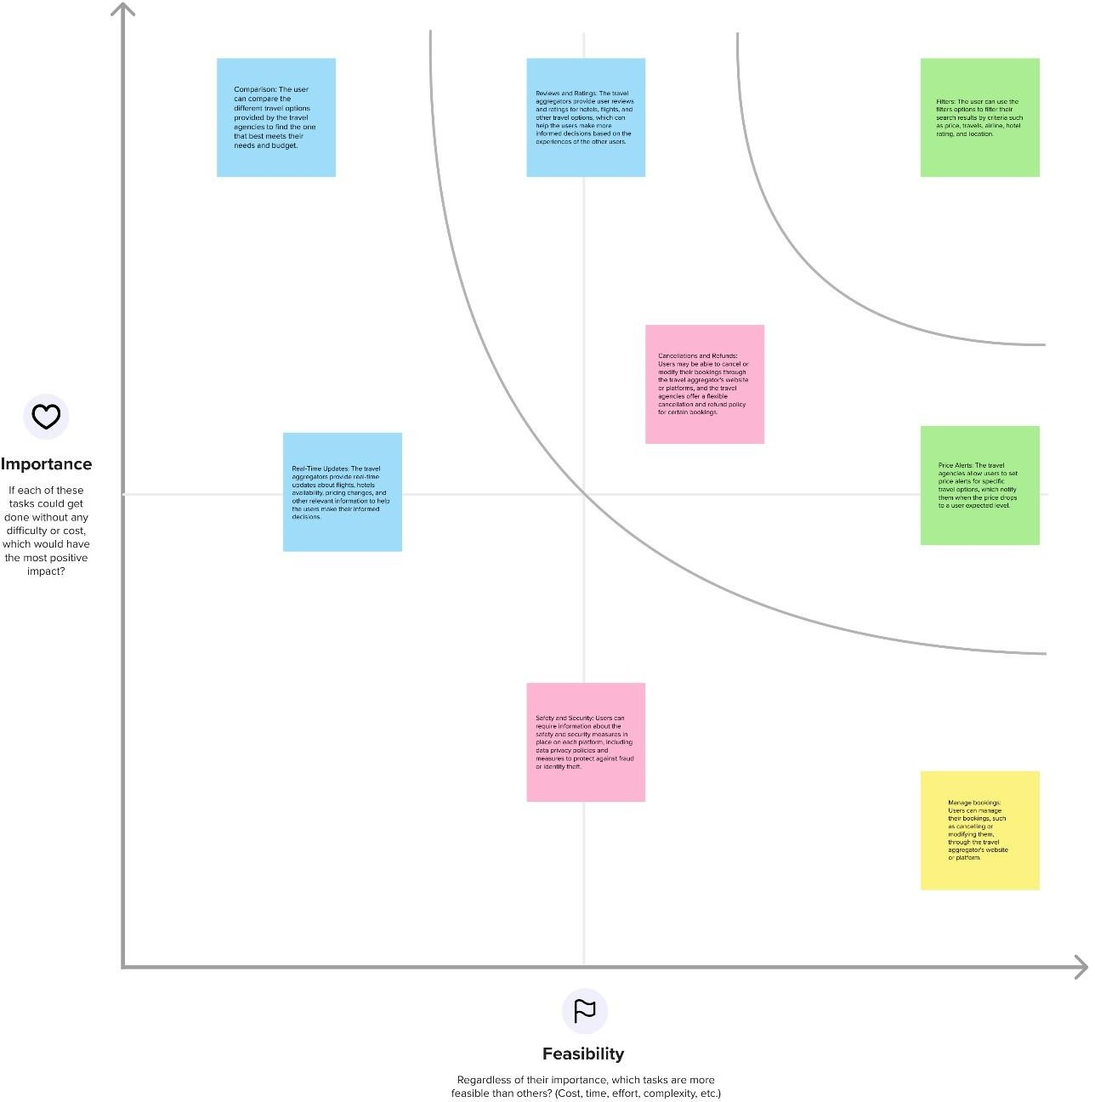

Fig 3.3.3 Idea Prioritization

## Proposed solution

|  |  |  |
| --- | --- | --- |
| **S.**  **No** | **Parameter** | **Description** |
| 1. | Problem Statement (Problem to be solved) | The problem statement is to analyze the leading travel aggregator using data analytics and python. A website needs to be built which is integrated with python, IBM Cognos, IBM DB2. The solution should satisfy the following user requirements:   * User friendly interface * Provide detailed information. * Day to Day prices and offers update. * Predictive analysis |
| 2. | Idea / Solution description | A travel aggregator is a user-friendly website that allows users to search and compare prices and offers for flights, hotels, vacation rentals provided by various travel aggregators. The website contains extra features for customer such as review, ratings, and images to assist customers in making informed decisions. We can analyze these details by python  and IBM Cognos. |
| 3. | Novelty / Uniqueness | * Evaluate the breadth and depth of travel offerings. * Reviews and Ratings. * Day to Day Updates. * Search, Filter and Compare options. * Cancellations and refunds. |
| 4. | Social Impact / Customer Satisfaction | Fraudulent activities can be prevented. Customers are satisfied in all aspects such as safety and security, trustworthy website, Time saving by search and filter options, Day to Day updates, and Reviews and Ratings |

|  |  |  |
| --- | --- | --- |
| 5. | Business Model (Revenue Model) | Most of the time, travel aggregators generate revenue by charging commissions to the travel providers whose products and services are featured on their website. Some also earn revenue through advertising, or by offering some additional services such as travel insurance or car rental, etc. |
| 6. | Scalability of the Solution | The website can further extend to provide Application Programming Interface (API) which can be used by third party organizations such as Cloud computing, Automation, Insurance companies, Travel agencies, etc. |

**REQUIREMENT ANALYSIS**



# CHAPTER 4 REQUIREMENT ANALYSIS

## Functional Requirements

|  |  |  |
| --- | --- | --- |
| **FR**  **No.** | **Functional Requirement (Epic)** | **Sub Requirement (Story / Sub-Task)** |
| FR- 1 | User Registration | Registration through Form Registration through Website Registration through Gmail |
| FR- 2 | User Confirmation | Confirmation via Email Confirmation via OTP Confirmation via Phone Call Confirmation via Social Media Integration |
| FR- 3 | User Dashboard | Evaluate Services and Features Pricing and Deals Analysis View User History and Ratings |
| FR- 4 | User profile and Preferences | Create and manage their profile. Allow users to change their privacy preferences and profile information as necessary. |
| FR- 5 | Output Generation | Report Generation Content Generation Itinerary Generation Visual Representation |

15 **NM2023TMID01791**

## Non-Functional Requirements

|  |  |  |
| --- | --- | --- |
| **FR**  **No.** | **Non-Functional Requirement** | **Description** |
| NFR- 1 | Usability | User-friendly Interface to facilitate the user with easy processing.  Model provides Analyze and Compare  Model provides Data Gathering Model provides Evaluation Criteria Model provides Visual  Representation of Prediction |
| NFR- 2 | Security | Authentication-User can have his/her own private dashboard to have secured access |
| NFR- 3 | Reliability | The model can run numerous samples simultaneously and handle massive amounts of data |
| NFR- 4 | Performance | As the model is a combination of python programming, the accuracy is  high |
| NFR- 5 | Availability | The website is portable and mobile- responsive as well. To run on any device, it simply needs the most minimum requirements |
| NFR- 6 | Scalability | It can be extended further to provide API which can be used by third party  organizations such as Logistics companies, etc. |
| NFR- 7 | Compliance | It makes sure that all legal criteria are met, and this includes travel industry rules as well as payment card  industry standards |

16 **NM2023TMID01791**

**PROJECT DESIGN**



# CHAPTER 5

* 1. **Data Flow Diagrams**

# PROJECT DESIGN

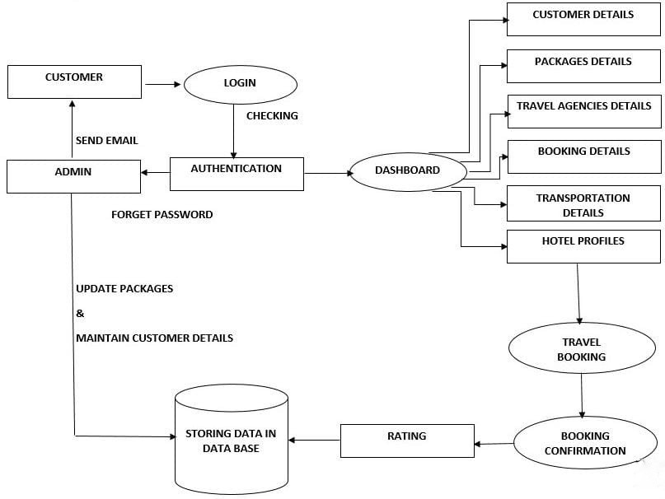

Fig 5.1 Data Flow Diagram of Travel Aggregator

## Solution & Technical Architecture

* + 1. **Solution Architecture**

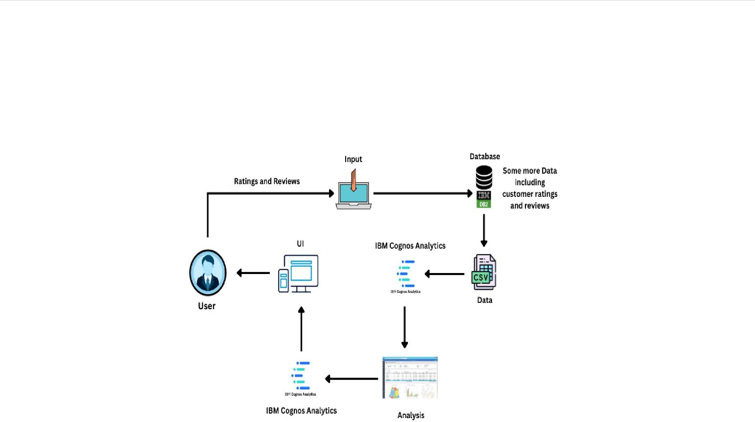

Fig 5.2.1 Solution Architecture of Travel Aggregator

## Technical Architecture

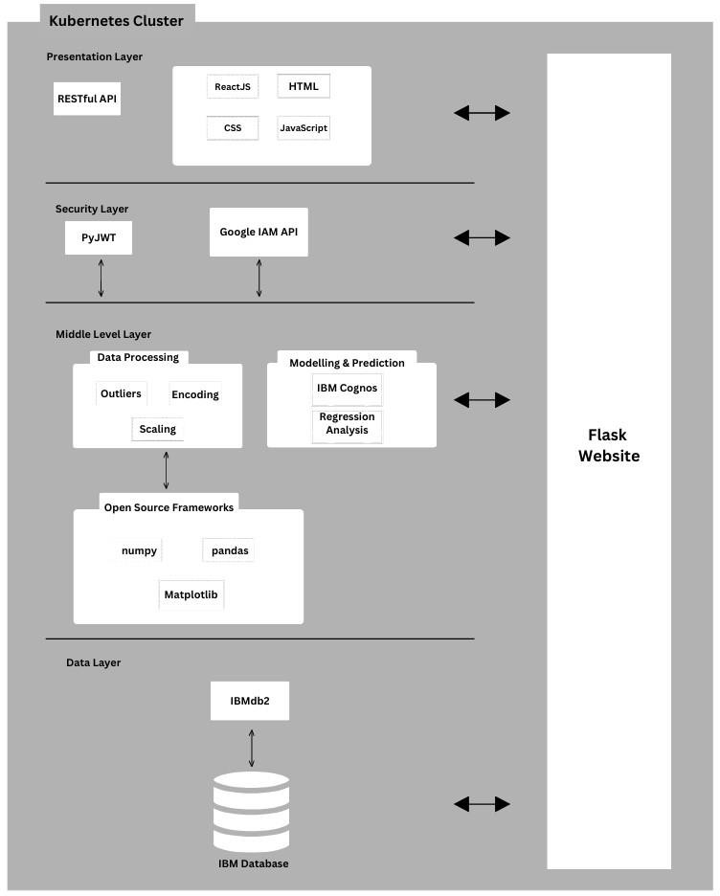

Fig 5.2.2 Technical Architecture of Travel Aggregator

## User Stories

|  |  |  |  |  |  |  |
| --- | --- | --- | --- | --- | --- | --- |
| **User Type** | **Functional**  **Requirement (Epic)** | **User**  **Story Number** | **User Story / Task** | **Acceptance criteria** | **Priority** | **Release** |
| Customer | Registration/ Login | USN-1 | As a  customer, I can login to the dashboard through  authentication | I can access the dashboard | High | Sprint- 3 |
|  | Dashboard | USN-2 | Once, I enter the dashboard, I can enter my  personal details | I can view the package details | High | Sprint- 1 |
|  |  | USN-3 | As a customer I can select the  traveling packages | I can select traveling agencies | Medium | Sprint- 2 |
|  |  | USN-4 | After considering the ratings of the traveling agencies, I can start the  booking process | I can enter the transportation details | High | Sprint- 1 |
|  |  | USN-5 | I can view the hotel profiles near the destination  place | I can book the hotel as per my convenience | Medium | Sprint- 1 |
| Admin |  | USN-6 | Once, I completed all the process I can move to the booking  confirmation | Admin confirms the booking transaction | Medium | Sprint- 1,2,3,4 |

|  |  |  |  |  |  |  |
| --- | --- | --- | --- | --- | --- | --- |
| Customer | Ratings | USN-7 | As a | Ratings and | Low | Sprint-4 |
|  |  |  | customer, | customer |  |  |
|  |  |  | after | booking details |  |  |
|  |  |  | booking | are stored in a |  |  |
|  |  |  | confirmation | data base by the |  |  |
|  |  |  | I can give | admin |  |  |
|  |  |  | ratings about |  |  |  |
|  |  |  | the user |  |  |  |
|  |  |  | experience. |  |  |  |
| Developer |  | USN-8 | I can access | Package details, | Medium | Sprint-4 |
|  |  | the | travel agencies, |  |  |
|  |  | dashboard | hotel profiles are |  |  |
|  |  | and view the | updated |  |  |
|  |  | ratings from | according to the |  |  |
|  |  | the customer | ratings |  |  |
|  |  | USN-9 | As a | I can request | High | Sprint-4 |
|  | developer, I | access for data |  |  |
|  | can update | base from the |  |  |
|  | the package | admin and update |  |  |
|  | details & | the data as soon |  |  |
|  | ratings to the | as possible |  |  |
|  | data base |  |  |  |
|  | and make |  |  |  |
|  | the data |  |  |  |

**CODING & SOLUTIONING**



# CHAPTER 6

**CODING & SOLUTIONING**

## Feature-1 DASHBOARD

<!DOCTYPE html>

<html lang="en">

<head>

<meta charset="UTF-8">

<meta http-equiv="X-UA-Compatible" content="IE=edge">

<meta name="viewport" content="width=device-width, initial- scale=1.0">

<title>Dashboard</title>

<link href="\static\css\style.css" rel="stylesheet">

</head>

<body>

<section id="dashboard" class="services section-bg">

<div class="container" data-aos="fade-up">

<div class="section-title">

<h2>Dashboard</h2>

</div>

<div class="row">

<iframe src="https://us3.ca.analytics.ibm.com/bi/?perspective=dashboard&amp;path Ref=.my_folders%2FTravel%2BAggregators%2BDashboard&amp;closeWi

ndowOnLastView=true&amp;ui_appbar=false&amp;ui_navbar=false&amp; shareMode=embedded&amp;action=view&amp;mode=dashboard&amp;sub View=model000001882006b5d9_00000002" width="1600" height="700" frameborder="0" gesture="media" allow="encrypted-media" allowfullscreen=""></iframe>

</div>

</div>

</section>

</body>

</html>

# Feature-2

## Report

<!DOCTYPE html>

<html lang="en">

<head>

<meta charset="UTF-8">

<meta http-equiv="X-UA-Compatible" content="IE=edge">

<meta name="viewport" content="width=device-width, initial- scale=1.0">

<title>Story</title>

<link href="\static\css\style.css" rel="stylesheet">

</head>

<body>

<section id="report" class="services section-bg">

<div class="container" data-aos="fade-up">

<div class="section-title">

<h2>Report</h2>

</div>

<div class="row">

<iframe src="https://us3.ca.analytics.ibm.com/bi/?pathRef=.my_folders%2FTravel% 2BAggregators%2BActive%2BReport&amp;closeWindowOnLastView=tru e&amp;ui_appbar=false&amp;ui_navbar=false&amp;shareMode=embedded &amp;action=run&amp;prompt=false" width="1600" height="700" frameborder="0" gesture="media" allow="encrypted-media"

allowfullscreen=""></iframe>

</div>

</div>

</section>

</body>

</html>

# Feature-3

## Story

<!DOCTYPE html>

<html lang="en">

<head>

<meta charset="UTF-8">

<meta http-equiv="X-UA-Compatible" content="IE=edge">

<meta name="viewport" content="width=device-width, initial- scale=1.0">

<title>Story</title>

<link href="\static\css\style.css" rel="stylesheet">

</head>

<body>

<section id="story" class="services section-bg">

<div class="container" data-aos="fade-up">

<div class="section-title">

<h2>Story</h2>

</div>

<div class="row">

<iframe src="https://us3.ca.analytics.ibm.com/bi/?perspective=story&amp;pathRef=. my_folders%2FTravel%2BAggregators%2Bstory&amp;closeWindowOnLa stView=true&amp;ui_appbar=false&amp;ui_navbar=false&amp;shareMode

=embedded&amp;action=view&amp;sceneId=model00000188203b1125_00 000000&amp;sceneTime=0" width="1600" height="700" frameborder="0"

gesture="media" allow="encrypted-media" allowfullscreen=""></iframe>

</div>

</section>

</body>

</html>

## Database Schema

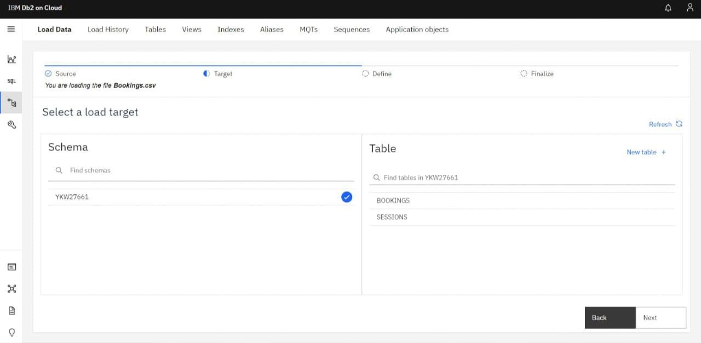

**RESULTS**



# CHAPTER 7 RESULTS

## Performance metrices

* + 1. Amount of data rendered to DB2.

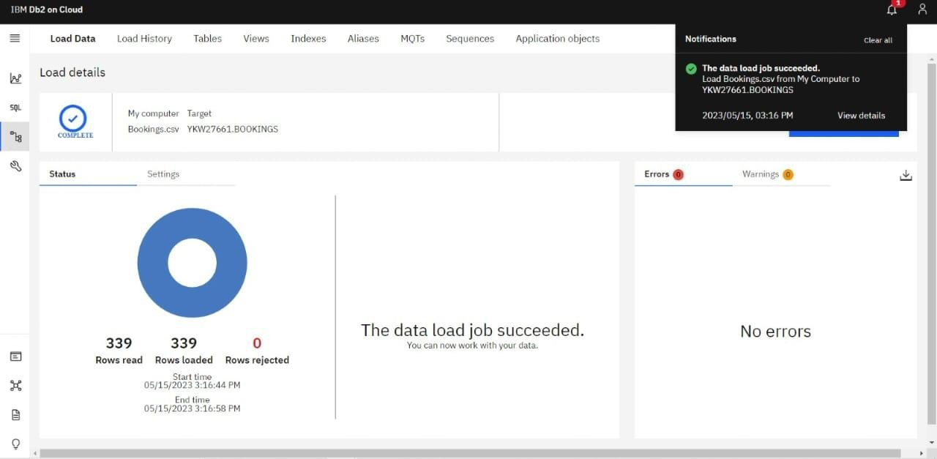

* + 1. Utilization of Data filters

## Dashboard

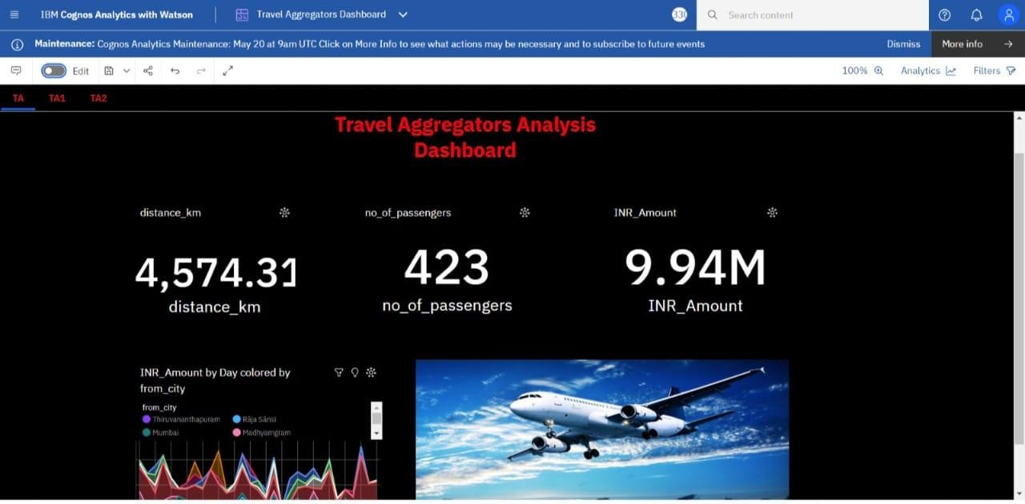

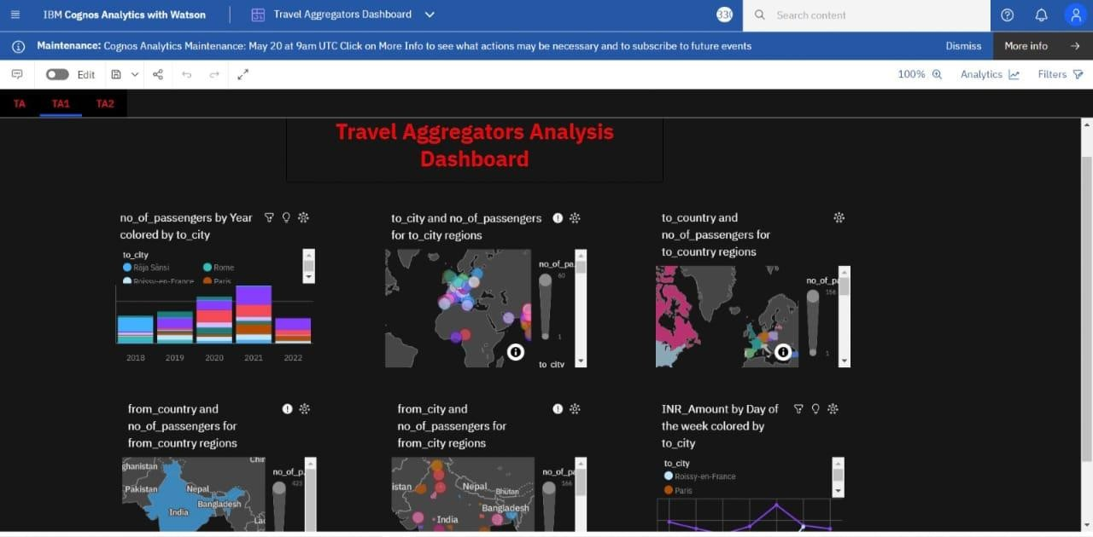

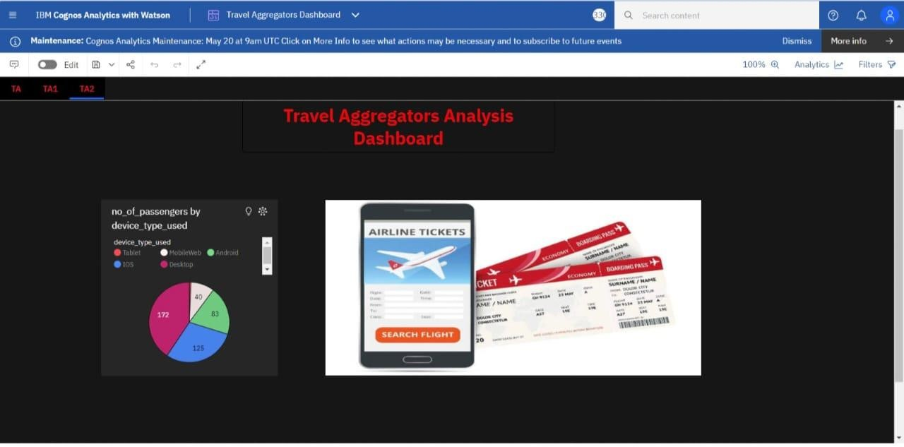

**Story**

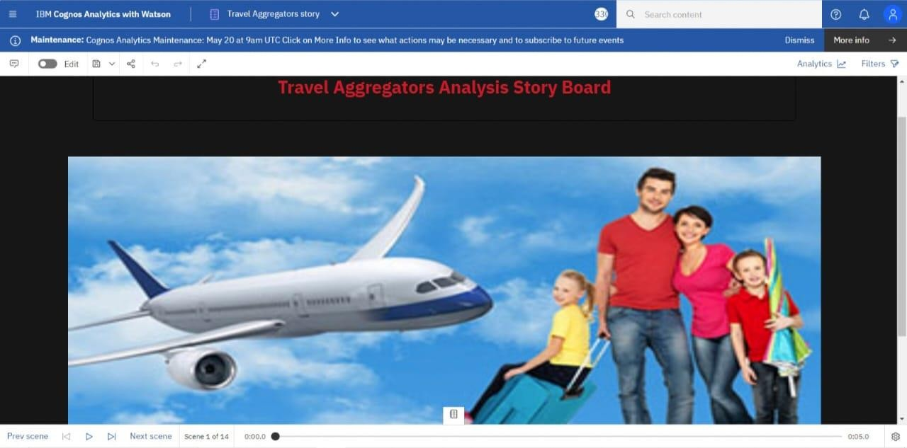

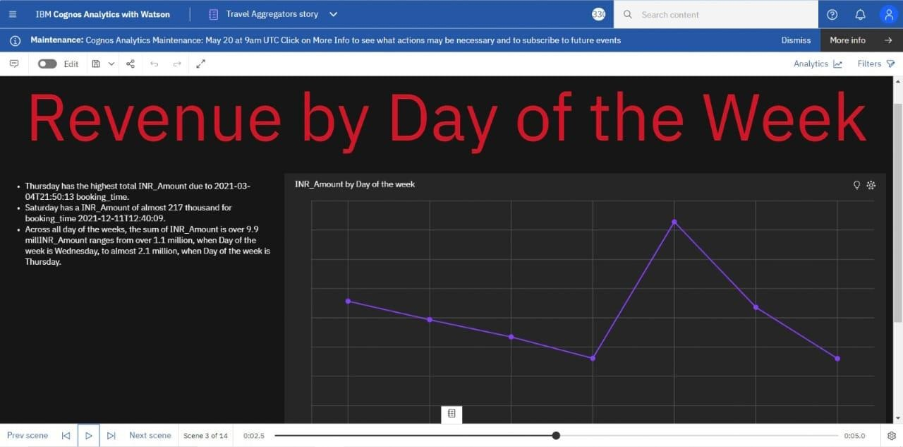

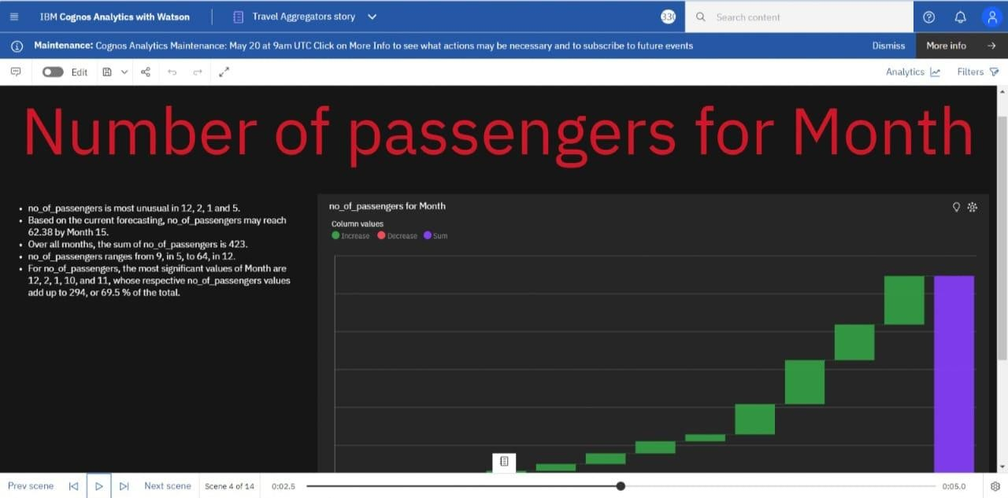

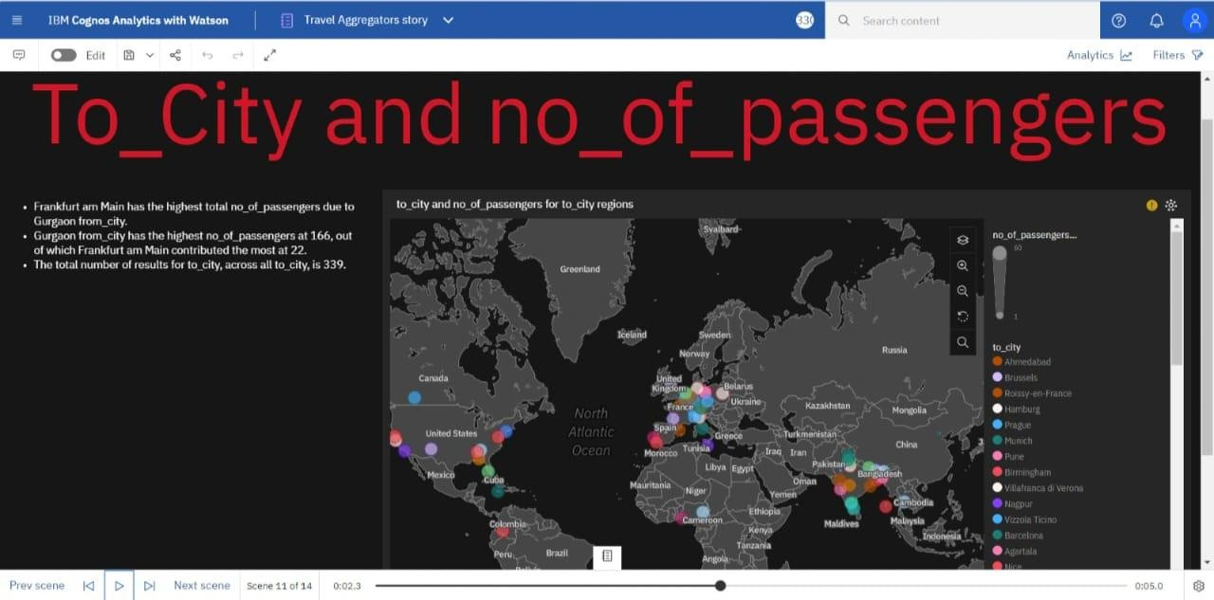

## Report

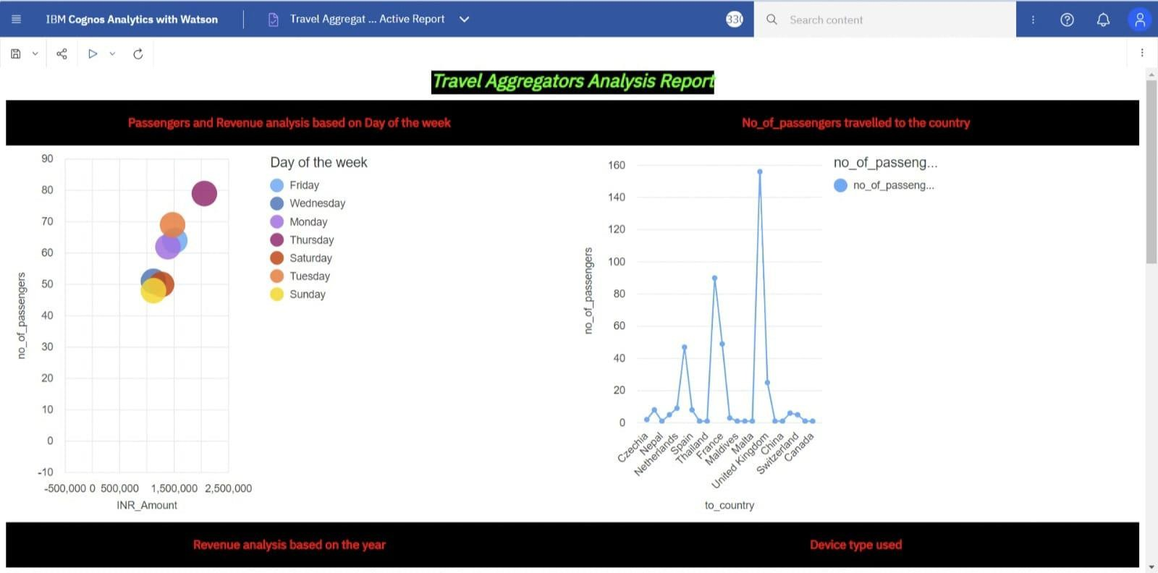

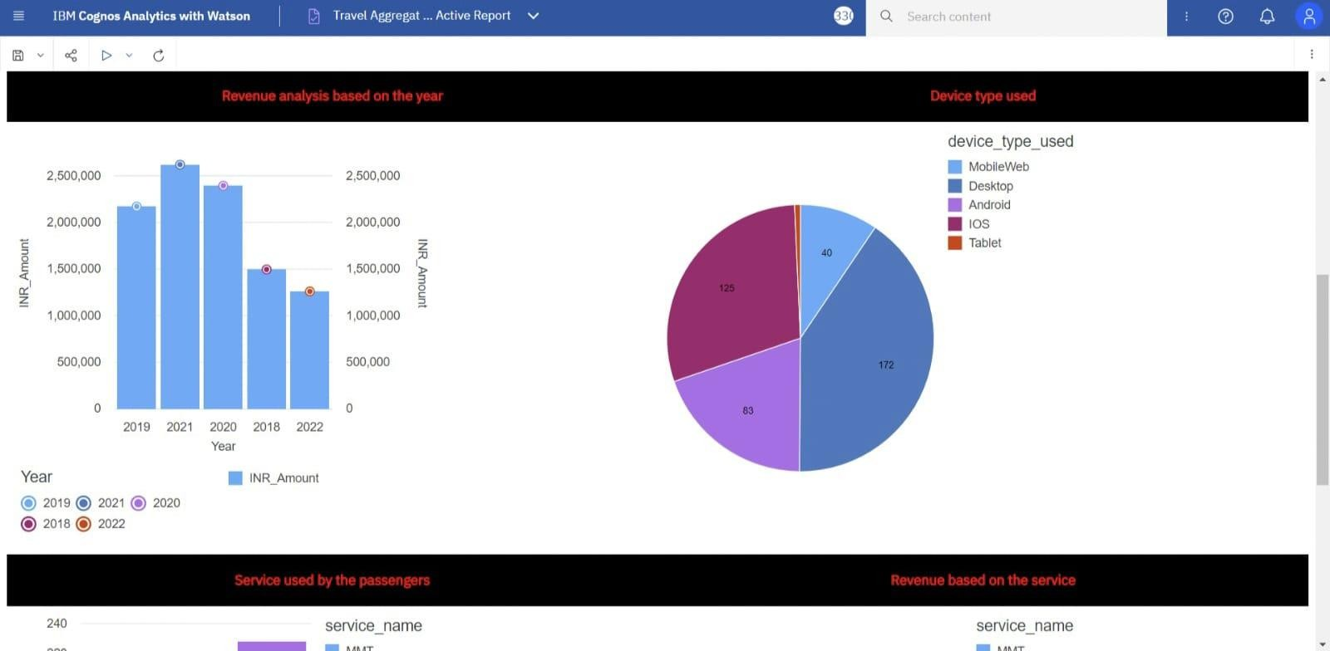

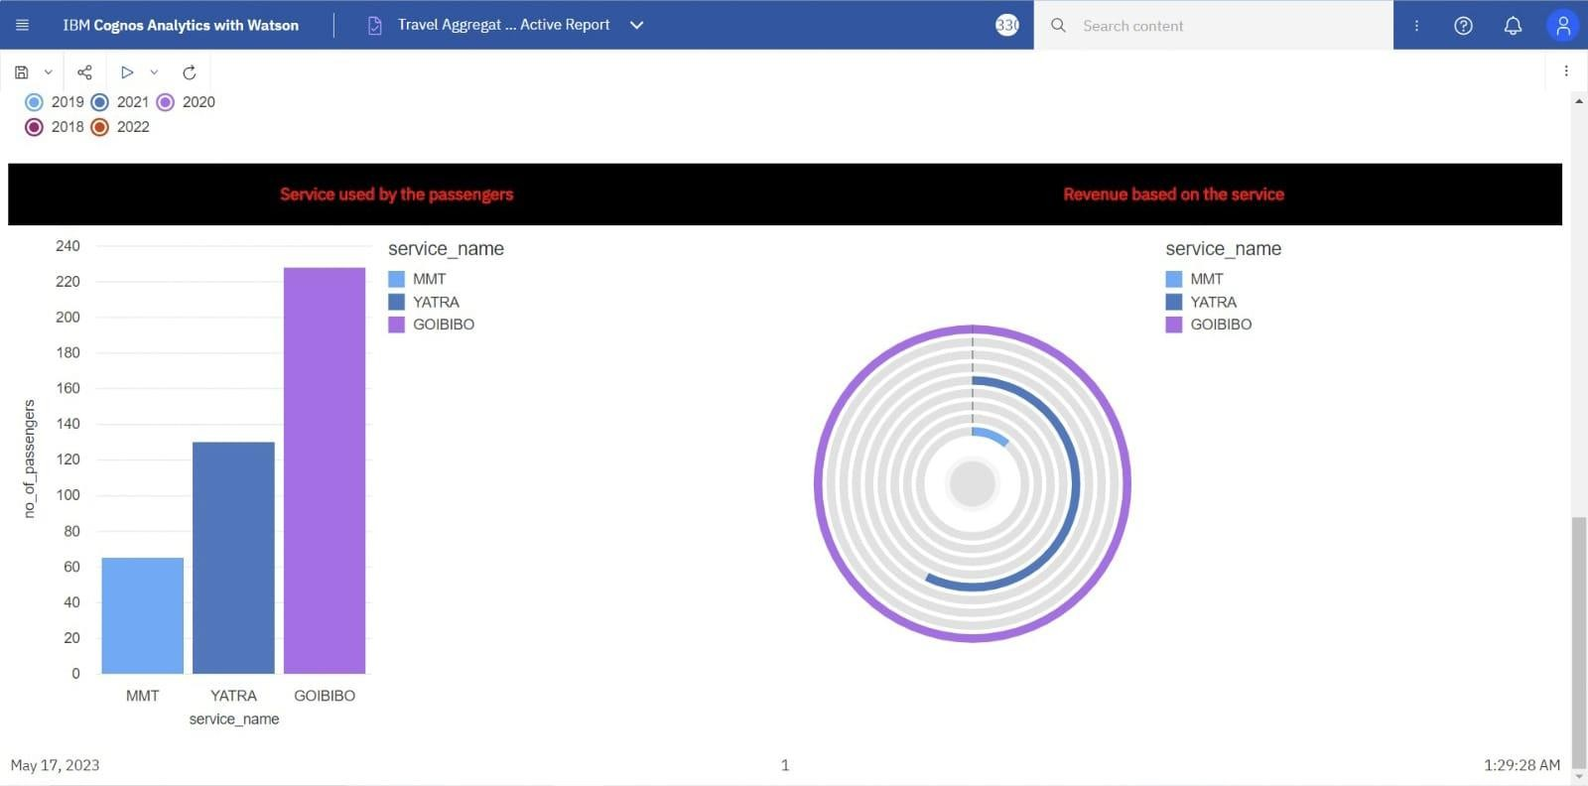

* + 1. **No. of. Calculation Fields**

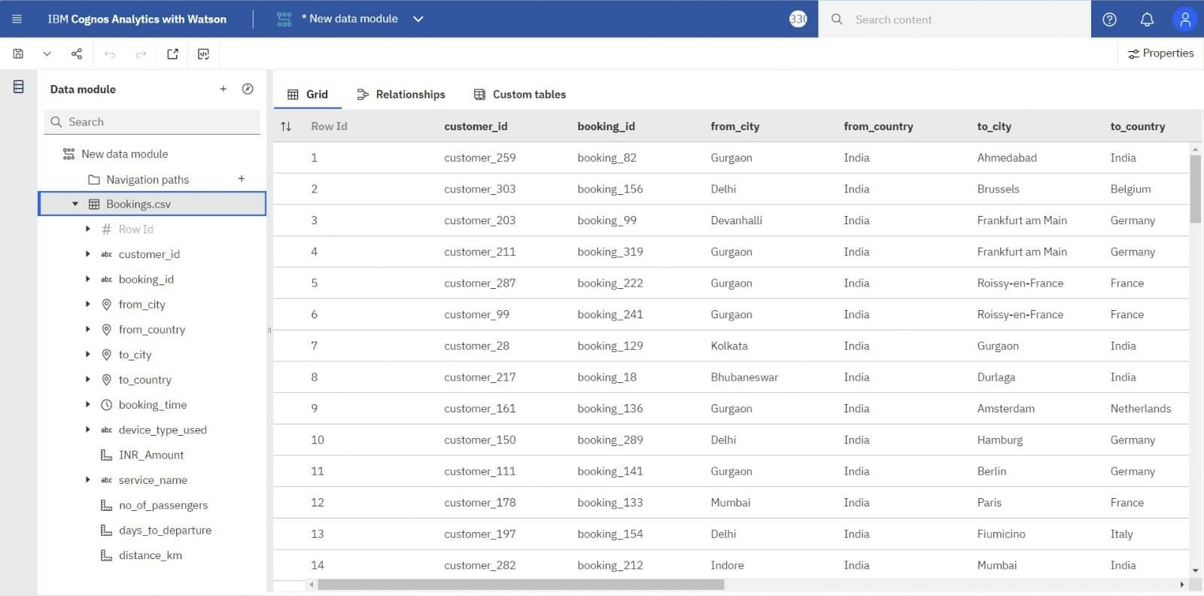

## No. of. Visualizations/Graphs

* + - 1. Total Distance covered by the Agencies.

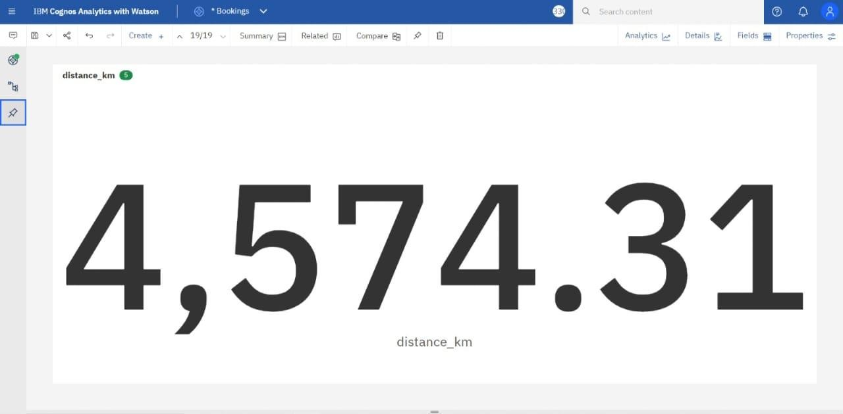

* + - 1. Total Revenue Generated and Total No of Passengers.

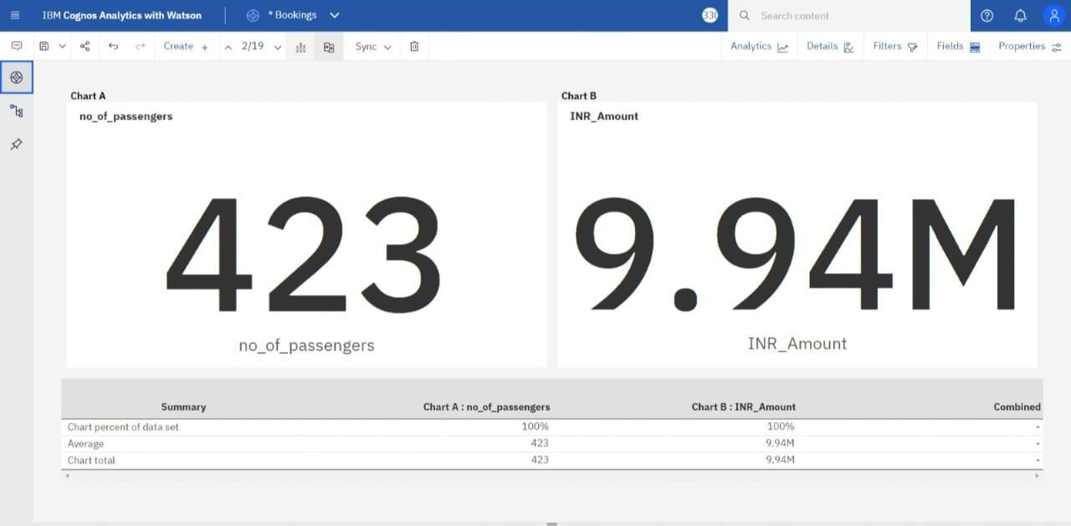

* + - 1. Passenger Analysis according to the day

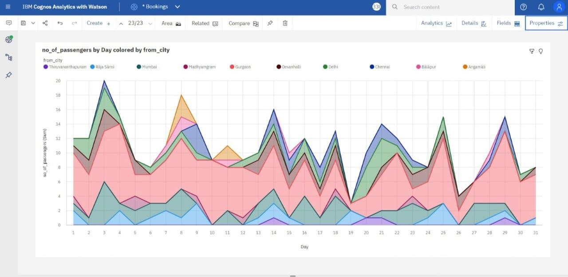

* + - 1. Passenger Analysis according to the year

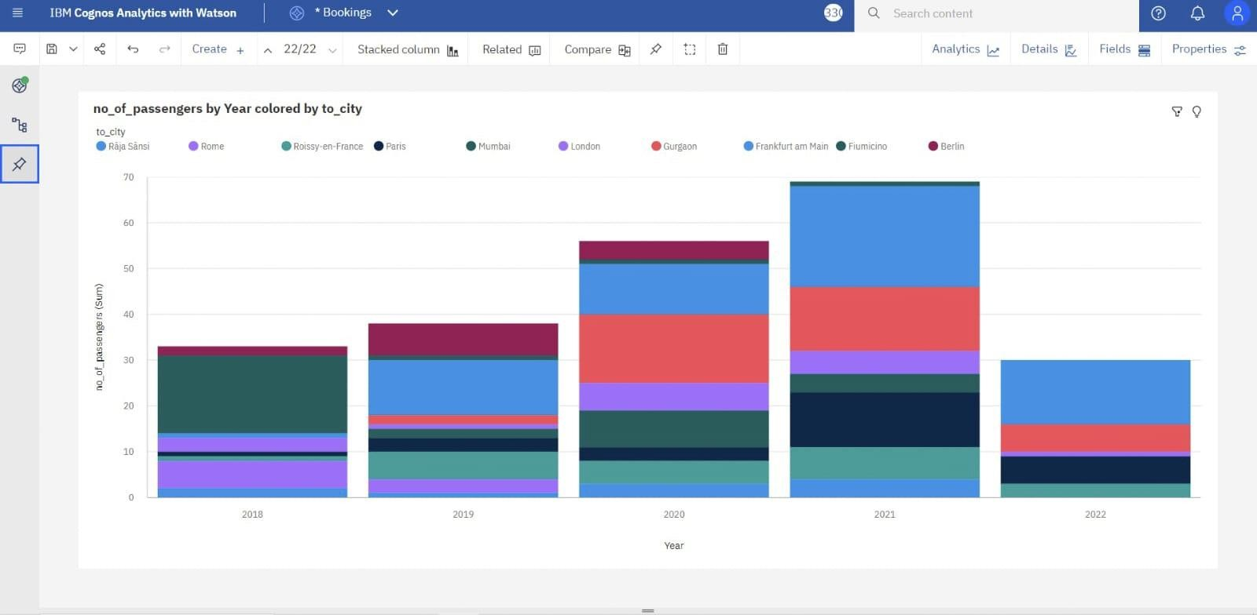

* + - 1. Passenger Analysis as per Destination Country and City

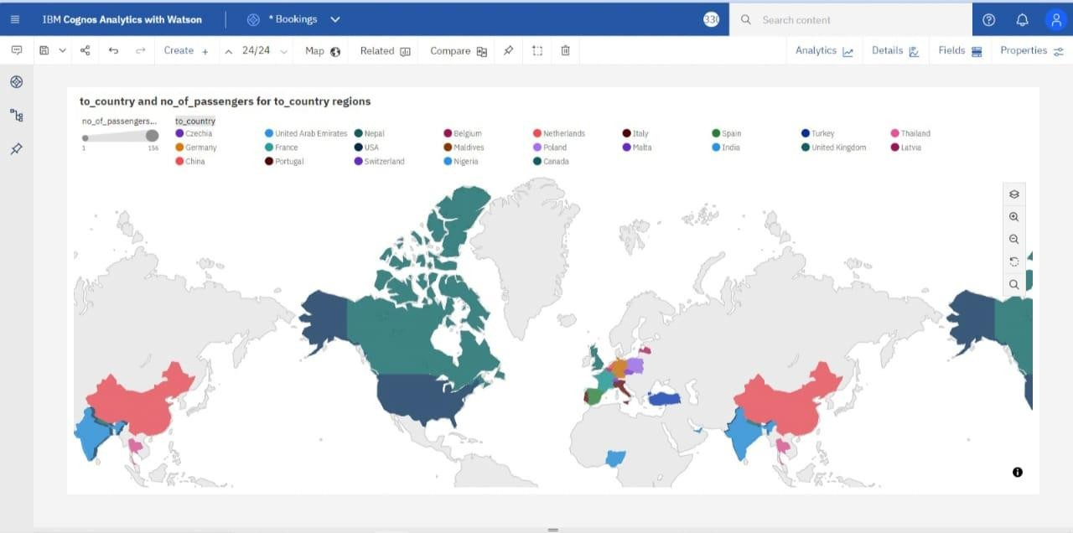

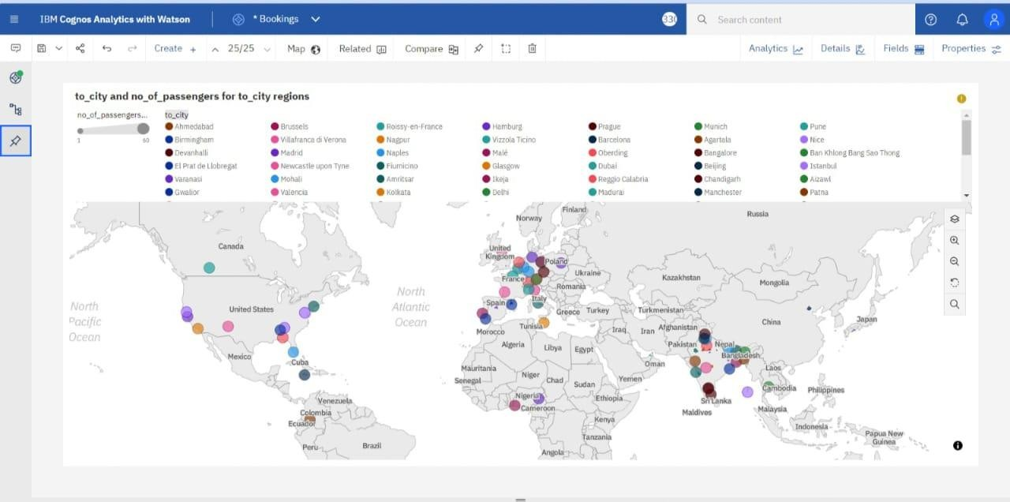

* + - 1. Passenger Analysis as per Source Country and City

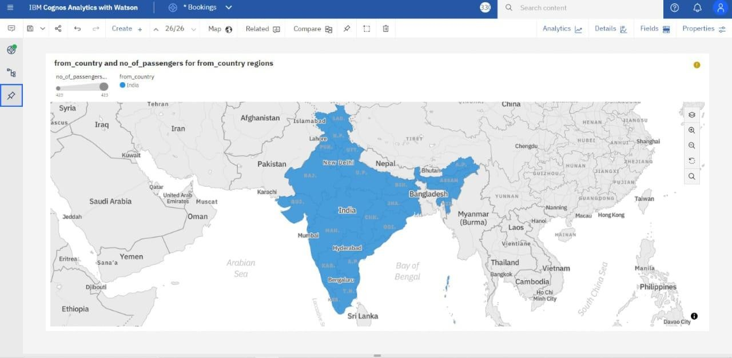

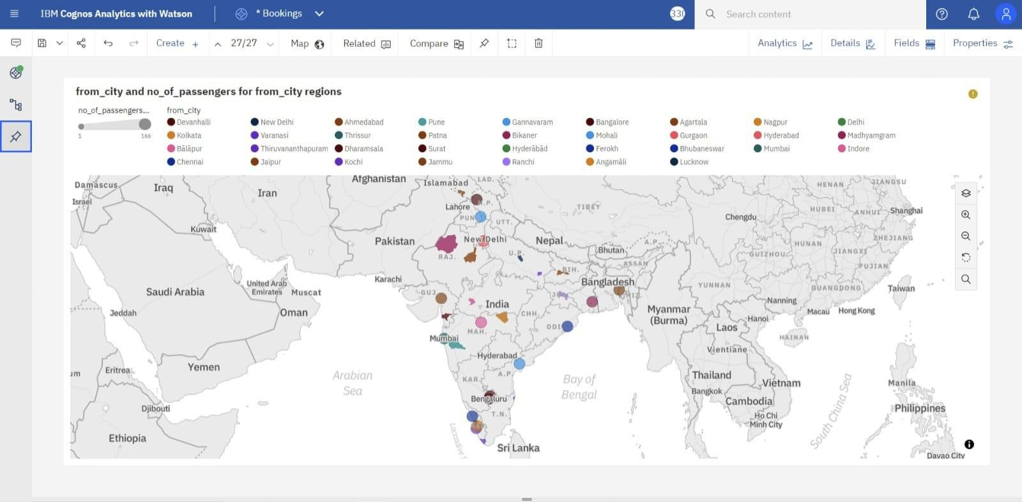

* + - 1. Total Revenue Generated According to day wise.

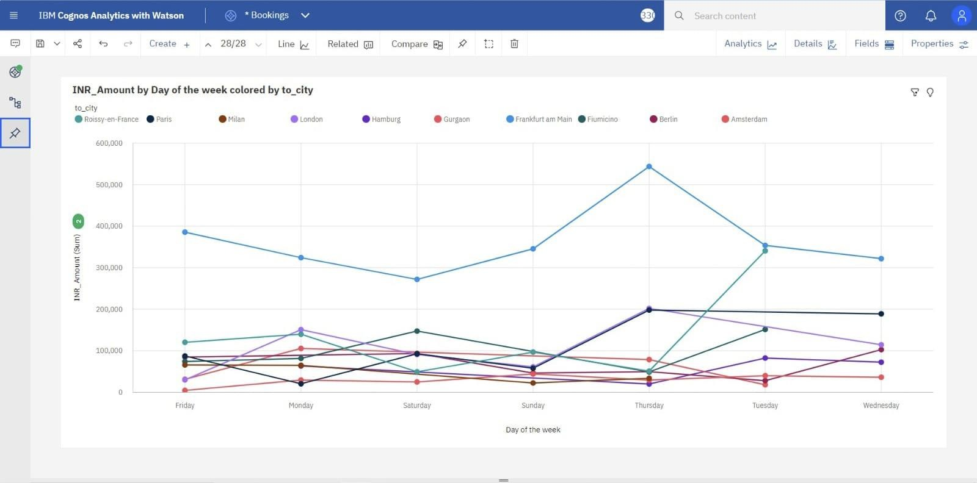

* + - 1. Passenger boo

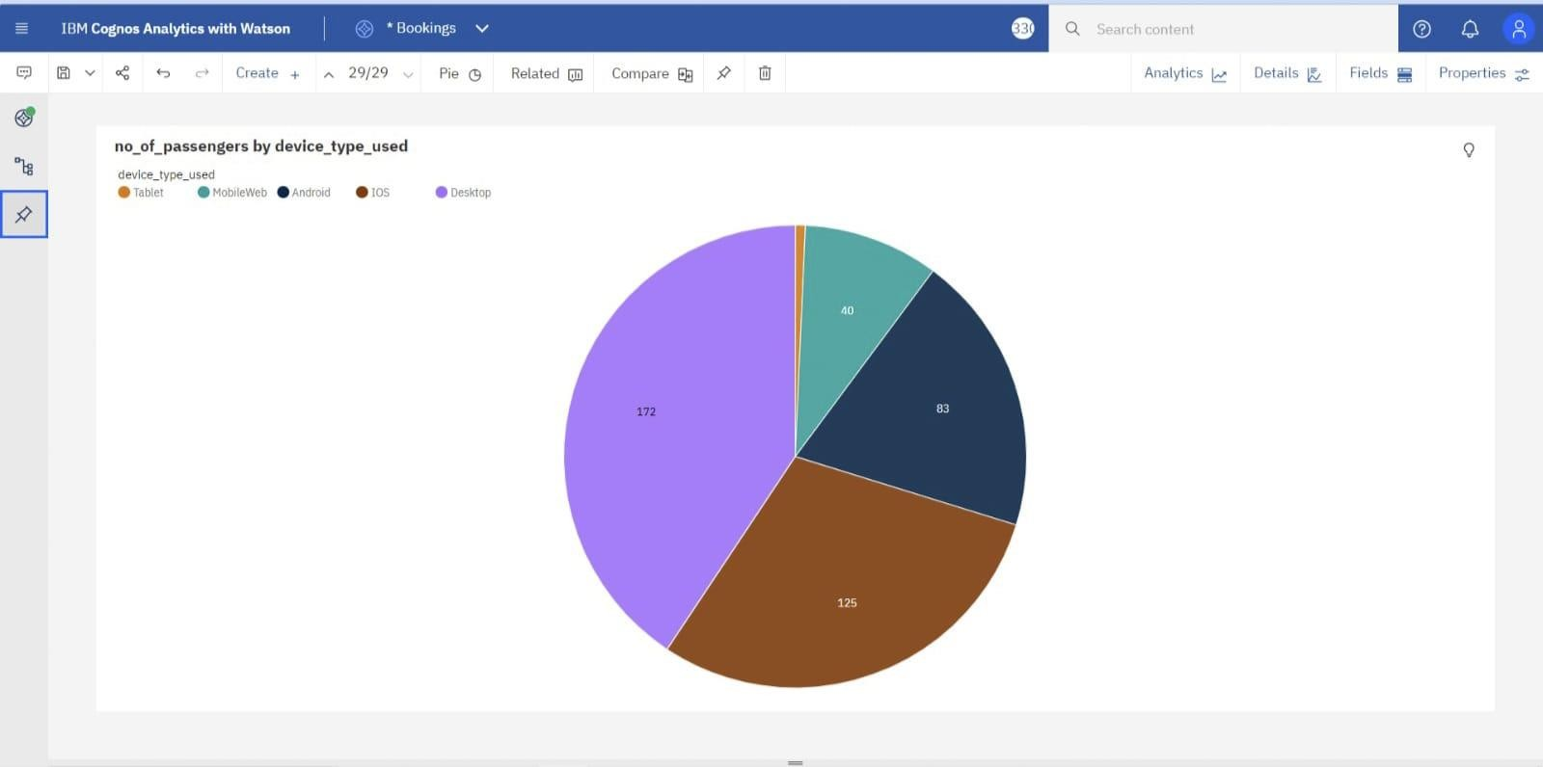

# ADVANTAGES AND DISADVANTAGES



**CHAPTER 8 ADVANTAGES AND DISADVANTAGES**

## Advantages

* + 1. Convenience: Travel aggregators provide a one-stop platform for planning and booking various aspects of travel, including flights, hotels, car rentals, and activities. Instead of visiting multiple websites or contacting different service providers individually, travelers can conveniently compare and book their desired options in one place.
    2. Timesaving: By using travel aggregators, travelers can save significant time in searching for the best deals. These platforms typically display multiple options with prices, ratings, and reviews, allowing users to quickly compare and make informed decisions without extensive research.
    3. Wide range of choices: Travel aggregators aggregate information from various travel providers, offering users a vast selection of flights, accommodations, and activities. This allows travellers to choose from a wide range of options that suit their preferences, budget, and specific needs.
    4. User reviews and ratings: Most travel aggregators include user reviews and ratings for hotels, airlines, and other services. These reviews provide valuable insights and help travelers make more informed decisions about their bookings. Users can read about others' experiences, assess the quality of services, and make choices accordingly.
    5. Additional services: Apart from flights and accommodations, travel aggregators often offer additional services such as travel insurance, airport transfers, and tour packages. This saves travelers the hassle of arranging these services separately and provides added convenience.

## Disadvantages

* + 1. Limited customization: Travel aggregators often provide pre- packaged deals or standard options that may not fully cater to individual preferences or specific requirements. If you have unique travel needs or preferences, such as specific room preferences or complex itineraries, it may be challenging to find precisely what you're looking for through a travel aggregator.
    2. Lack of personalization: Since travel aggregators cater to a wide audience, the booking process may lack personalization. You may not receive personalized recommendations or tailored assistance that you would typically get when working directly with a travel agent or service provider.
    3. Hidden fees and restrictions: While travel aggregators may offer competitive pricing, it's important to carefully review the terms and conditions, as there may be hidden fees or restrictions that are not immediately apparent. These can include additional charges for baggage, cancellation fees, or limitations on refunds and changes.

# CONCLUSION



**CHAPTER 9 CONCLUSION**

Online Travel Agencies (OTAs) or travel aggregators have transformed the way people plan, book, and experience travel. They offer a range of advantages, such as convenience, time savings, competitive pricing, a wide selection of choices, user reviews, additional services, customer support, and loyalty programs. OTAs provide a centralized platform where travelers can easily compare options, access discounted rates, and make informed decisions.

However, there are also some disadvantages to consider. OTAs may lack customization and personalization, have hidden fees and restrictions, rely on third-party information, and have limitations in customer service. The overwhelming number of choices and the influence of commission-based models can also pose challenges for travelers.

Looking ahead, the future scope of travel aggregators is promising. Advancements in technology, such as enhanced personalization, AR/VR integration, blockchain and smart contracts, and a mobile-first approach, can enhance the user experience and offer more seamless and secure travel bookings. Furthermore, the industry can embrace sustainability, community- driven features, and cater to emerging markets to meet the evolving needs and preferences of travelers.

Ultimately, whether to use an OTA or explore alternative booking methods depends on individual preferences and travel requirements. It is essential for

travelers to consider the pros and cons, evaluate their specific needs, and make an informed decision that best aligns with their travel goals.

# FUTURE SCOPE



**CHAPTER 10**

# FUTURE SCOPE

1. Enhanced personalization: Travel aggregators are likely to invest more in advanced algorithms and artificial intelligence to provide personalized travel recommendations. By analyzing user preferences, behavior, and past bookings, aggregators can offer tailored suggestions and options that match individual travelers' preferences, making the booking process more convenient and efficient.
2. Augmented Reality (AR) and Virtual Reality (VR): The integration of AR and VR technologies can revolutionize the way travelers explore and experience destinations. Travel aggregators may incorporate these immersive technologies to provide virtual tours, 360-degree views of accommodations, and interactive experiences, allowing travelers to make more informed decisions and have a better understanding of what to expect.
3. Blockchain and Smart Contracts: The use of blockchain technology can enhance transparency, security, and trust in travel bookings. Travel aggregators can leverage blockchain to streamline payment processes, reduce fraud, and facilitate direct communication and transactions between travelers and service providers. Smart contracts can automatically execute and enforce terms and conditions, ensuring a seamless and secure booking experience.
4. Integration of ancillary services: Travel aggregators can expand their offerings beyond flights and accommodations by integrating more ancillary services. This may include seamless integration with local transportation providers, restaurant reservations, event tickets, and other travel-related

services. By becoming comprehensive travel platforms, aggregators can offer a more holistic and convenient travel experience.

1. Sustainability and eco-friendly travel: With increasing awareness and emphasis on sustainability, travel aggregators can promote eco-friendly travel options. They can highlight accommodations with green certifications, carbon offset programs for flights, encouraging travellers to make conscious ch

# APPENDIX



**CHAPTER 11 APPENDIX**

## Source code

**Flask code app.py**

from flask import Flask, render_template from flask_cors import CORS

app = Flask(_name_) CORS(app)

@app.route("/") def ibm():

return render_template("ibm.html")

@app.route("/dashboard") def dashboard():

return render_template("dashboard.html")

@app.route("/story") def story():

return render_template("story.html")

@app.route("/report") def report ():

return render_template("report.html")

if _name_ == "_main_": app.run(debug=True)

## ibm.html

<header id="header" class="fixed-top ">

<div class="container d-flex align-items-center">

<h1 class="logo me-auto"><a href="index.html">ABDA</a></h1>

<!-- Uncomment below if you prefer to use an image logo -->

<!--<ahref="index.html"class="logome-auto"><img src="assets/img/logo.png" alt="" class="img-fluid"></a>-->

<nav id="navbar" class="navbar">

<ul>

<li><a class="nav-link scrollto active" href="#hero">Home</a></li>

<li><a class="nav-link scrollto" href="#about">About</a></li>

<li><a class="nav-link scrollto" href="#services">Services</a></li>

<li><a class="nav-link scrollto" href="#portfolio">Portfolio</a></li>

<li><a class="nav-link scrollto" href="#team">Team</a></li>

<li class="dropdown"><a href="#"><span>Drop Down</span> <i class="bi bi-chevron-down"></li></a>

<ul>

<li><a href="/dashboard">Dashboard</a></li>

<ul>

<li><a href="/dashboard">Dashboard</a></li>

<li><a href="/story">Story</a></li>

<li><a href="/report">Report</a></li>

</ul>

</li>

<li><a href="/story">Story</a></li>

<li><a href="/report">Report</a></li>

</ul>

</li>

<li><a class="nav-link scrollto" href="#contact">Contact</a></li>

<li><a class="getstarted scrollto" href="#about">Get Started</a></li>

</ul>

<i class="bi bi-list mobile-nav-toggle"></i>

</nav><!-- .navbar -->

</div>

</header>

## dashboard.html

<!DOCTYPE html>

<html lang="en">

<head>

<meta charset="UTF-8">

<meta http-equiv="X-UA-Compatible" content="IE=edge">

<meta name="viewport" content="width=device-width, initial-scale=1.0">

<title>Dashboard</title>

<link href="\static\css\style.css" rel="stylesheet">

</head>

<body>

<section id="dashboard" class="services section-bg">

<div class="container" data-aos="fade-up">

<div class="section-title">

<h2>Dashboard</h2>

</div>

<div class="row">

<iframe src="https://us3.ca.analytics.ibm.com/bi/?perspective=dashboard&amp;path Ref=.my_folders%2FTravel%2BAggregators%2BDashboard&amp;closeWi ndowOnLastView=true&amp;ui_appbar=false&amp;ui_navbar=false&amp; shareMode=embedded&amp;action=view&amp;mode=dashboard&amp;sub View=model000001882006b5d9_00000002" width="1600" height="700" frameborder="0" gesture="media" allow="encrypted-media" allowfullscreen=""></iframe>

</div>

</div>

</section>

</body>

</html>

## story.html

<!DOCTYPE html>

<html lang="en">

<head>

<meta charset="UTF-8">

<meta http-equiv="X-UA-Compatible" content="IE=edge">

<meta name="viewport" content="width=device-width, initial-scale=1.0">

<title>Story</title>

<link href="\static\css\style.css" rel="stylesheet">

</head>

<body>

<section id="report" class="services section-bg">

<div class="container" data-aos="fade-up">

<div class="section-title">

<h2>Report</h2>

</div>

<div class="row">

<iframe src="https://us3.ca.analytics.ibm.com/bi/?pathRef=.my_folders%2FTravel% 2BAggregators%2BActive%2BReport&amp;closeWindowOnLastView=tru e&amp;ui_appbar=false&amp;ui_navbar=false&amp;shareMode=embedded &amp;action=run&amp;prompt=false" width="1600" height="700" frameborder="0" gesture="media" allow="encrypted-media" allowfullscreen=""></iframe>

</div>

</div>

</section>

</body>

</html>

## report.html

<!DOCTYPE html>

<html lang="en">

<head>

<meta charset="UTF-8">

<meta http-equiv="X-UA-Compatible" content="IE=edge">

<meta name="viewport" content="width=device-width, initial-scale=1.0">

<title>Story</title>

<link href="\static\css\style.css" rel="stylesheet">

</head>

<body>

<section id="report" class="services section-bg">

<div class="container" data-aos="fade-up">

<div class="section-title">

<h2>Report</h2>

</div>

<div class="row">

<iframe src="https://us3.ca.analytics.ibm.com/bi/?pathRef=.my_folders%2FTravel% 2BAggregators%2BActive%2BReport&amp;closeWindowOnLastView=tru e&amp;ui_appbar=false&amp;ui_navbar=false&amp;shareMode=embedded &amp;action=run&amp;prompt=false" width="1600" height="700" frameborder="0" gesture="media" allow="encrypted-media" allowfullscreen=""></iframe>

</div>

</div>

</section>

</body>

</html>

## GitHub & Project Video Demo Link

* + 1. **GitHub**

Link**: https://github.com/gnanavel2628/Naanmudhalvan-DataAnalytics-NM2023TMID01791**

## Project Demo Video

Link: https://www.youtube.com/watch?v=tqApsyuxydM